SaxStat PCB v04 Specification

Overview
The SaxStat PCB v04 is a low-cost, compact potentiostat designed for DIYers, electrochemical sensor developers, and educators. It is compatible with the ESP32-DevKitC-V4 (38-pin) development board, featuring female pin headers for easy integration. The PCB supports three-electrode electrochemical experiments (working electrode [WE], counter electrode [CE], reference electrode [RE]) for screen-printed electrodes, delivering reliable performance for cyclic voltammetry (CV) and other electrochemical techniques. The design prioritizes affordability, simplicity, and modularity, with a target sale price of ~$150.

Target Audience
- DIYers: Enthusiasts building custom electrochemical sensors or IoT projects.
- Electrochemical Sensor Developers: Researchers prototyping sensors for environmental, medical, or industrial applications.
- Educators: Instructors teaching electrochemistry or embedded systems in academic settings.

Key Features
- ESP32-DevKitC-V4 Compatibility: Female pin headers for direct plug-in of the 38-pin ESP32-DevKitC-V4 board, ensuring easy setup and prototyping.
- Three-Electrode System: Supports WE, CE, and RE for precise electrochemical measurements (macroelectrode focus, µA currents).
- Low-Cost Design: Total production cost ~$100 for 10 PCBs and components, leveraging JLCPCB manufacturing and assembly.
- Compact Form Factor: PCB dimensions optimized for breadboard compatibility and small enclosures (~50 mm x 50 mm, 2-layer FR4).
- User-Friendly Interface: PyQt5-based GUI for real-time data acquisition, plotting, and parameter control (e.g., scan rate, voltage range).
- Open-Source Firmware: Arduino-based firmware for ESP32, supporting CV and customizable electrochemical experiments.

Hardware Specifications

Microcontroller
- Module: ESP32-DevKitC-V4 with ESP32-WROOM-32E (4 MB flash, dual-core, 240 MHz, Wi-Fi, Bluetooth).
- Interface: Female pin headers (2x19, 38-pin layout, 2.54 mm pitch) for direct ESP32-DevKitC-V4 plug-in.
- GPIO Usage:
  - SPI: SCK (GPIO18), MOSI (GPIO23), CS (GPIO5) for DAC.
  - I2C: SDA (GPIO21), SCL (GPIO22) for ADC.
  - GPIO2, GPIO4 for analog switch control (TIA resistor selection).
  - Avoid D0, D1, D2, D3, CMD, CLK (SPI flash pins) to prevent conflicts, as per ESP32-DevKitC-V4 documentation.
- Power: USB-powered via ESP32-DevKitC-V4 (5 V, regulated to 3.3 V onboard).
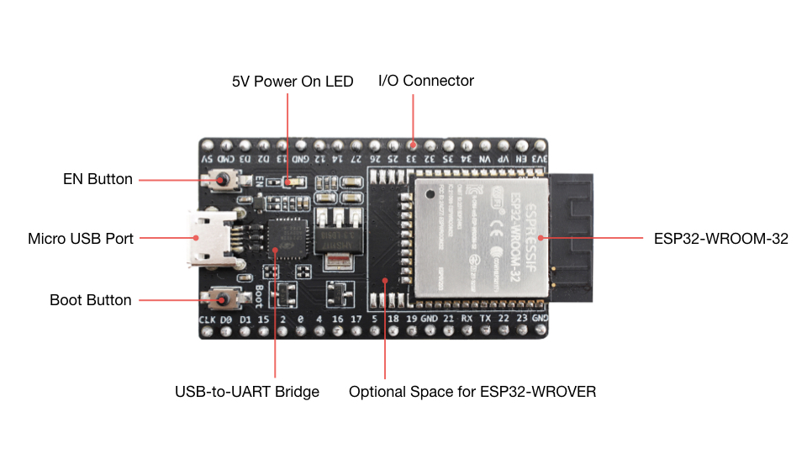

Digital-to-Analog Converter (DAC)
- Component: AD5761 (16-bit, ±3 V output, SPI interface).
- Voltage Range: -2.5 V to +2.5 V (configurable via firmware).
- Output: V_ramp to TIA input via low-pass filter (10 kΩ, 0.1 µF) for noise reduction.
- Reference: 2.5 V from ADR4525 for high precision.

Analog-to-Digital Converter (ADC)
- Component: ADS1115 (16-bit, I2C interface, 4.096 V reference).
- Input: Measures TIA output (OpC_OUT) via low-pass filter (10 kΩ, 0.1 µF).
- Reference: 2.5 V from ADR4525, with 1.0 V offset (ADR510) to ensure non-negative ADC input.

Transimpedance Amplifier (TIA)
- Component: LMC6484 (quad op-amp, rail-to-rail, 1.5 MHz bandwidth, ~1 nA noise floor, as used in v03 prototype).
- Configuration: Selectable feedback resistors (10 kΩ, 1 MΩ) via TS5A3160 analog switches for macroelectrode (µA) measurements.
- Feedback Capacitor: 10 pF to prevent oscillation, based on v03 testing.
- Note: LMP7721 (3 fA bias current) deferred to future versions for UME support (nA currents).

Analog Switches
- Component: TS5A3160 (single-channel, 5 V tolerant, low on-resistance).
- Function: Automated selection of TIA feedback resistors (10 kΩ, 1 MΩ) via ESP32 GPIO (GPIO2, GPIO4).
- Control: Firmware-driven, with GUI option for manual override.

Power Supply
- ICL7660: Generates ±3 V from 5 V USB input for op-amp and DAC/ADC references.
- Capacitors: 10 µF (C1, C2) for ICL7660, 0.1 µF for decoupling (C3–C6).
- Reference Voltage: ADR4525 (2.5 V, low-noise) for DAC and ADC.
- Grounding: Star-ground point near ICL7660 to minimize noise and ground loops.

Electrochemical Interface
- Connector: 3-pin terminal block (J2) for WE, CE, RE.
- Supported Experiments: Cyclic voltammetry (CV), linear sweep voltammetry (LSV), with macroelectrode focus (e.g., 75 µM ferrocenemethanol, as in SweepStat).
- Current Range: 100 nA to 100 µA (LMC6484-based TIA, 10 kΩ to 1 MΩ feedback).

PCB Specifications
- Layers: 2-layer FR4, 1.6 mm thickness.
- Dimensions: ~50 mm x 50 mm (fits JLCPCB $2 pricing for 5 PCBs).
- Trace Widths:
  - Power: 15–20 mil for ±3 V, 5 V, GND.
  - Analog: 10 mil for V_ramp, OpC_OUT.
  - Digital: 8–10 mil for SPI, I2C.
- Grounding: Bottom-layer ground plane with star-ground point and vias for top-layer GND pads.
- Test Points: V_ramp, OpC_OUT, VREF, ADC input (AIN0) for debugging.
- Connectors: Female pin headers (2x19, 38-pin, 2.54 mm pitch) for ESP32-DevKitC-V4, 3-pin terminal block (J2), jumper headers for manual TIA resistor selection.
- Silkscreen: Clear labels for J2 (WE, CE, RE), test points, and key components.

Firmware and Software
- Firmware: Arduino-based (SaxStat_V03_GUI_Test.ino as baseline), supporting:
  - SPI control for AD5761 (voltage ramp generation).
  - I2C control for ADS1115 (current measurement).
  - GPIO control for TS5A3160 (TIA resistor switching).
  - CV parameters: scan rate (10–1000 mV/s), voltage range (-2.5 V to +2.5 V).
- GUI: PyQt5-based (SaxStat_GUI_V03.py as baseline), featuring:
  - Real-time plotting of i-E curves.
  - User inputs for scan rate, voltage range, and TIA gain.
  - Data export to CSV for analysis.
- OTA Updates: Optional over-the-air firmware updates via ESP32 Wi-Fi, inspired by ESPHome recommendations.

Performance Metrics
- Resolution: 16-bit (AD5761 DAC, ADS1115 ADC).
- Voltage Range: -2.5 V to +2.5 V (configurable).
- Current Range: 100 nA to 100 µA (macroelectrode focus).
- Noise Floor: ~1 nA (LMC6484 TIA, sufficient for macroelectrodes; future LMP7721 for <10 pA).
- Scan Rate: 10–1000 mV/s for CV experiments.
- Accuracy: ±0.1% for voltage, ±1% for current (based on v03 prototype testing).

Cost Breakdown
- PCB Manufacturing: ~$2 for 5 PCBs (2-layer, 50 mm x 50 mm, JLCPCB).
- Components:
  - LMC6484: ~$2 each.
  - AD5761: ~$5 each.
  - ADS1115: ~$3 each.
  - TS5A3160: ~$0.50 each (x2).
  - ICL7660: ~$1 each.
  - ADR4525: ~$3 each.
  - Passives (resistors, capacitors): ~$2 total.
  - Connectors (J2, headers): ~$2 total.
- Total per PCB: ~$9–$10 (components) + ~$0.40 (PCB) = ~$10.
- Total for 5 PCBs: ~$50 (excluding shipping, ~$10–$20).

Design Constraints
- ESP32-DevKitC-V4 (38-pin):
  - Dimensions: 25.5 mm width, 2.54 mm pin pitch, 38 pins (2x19).
  - Avoid using D0, D1, D2, D3, CMD, CLK (SPI flash pins).
  - GPIO16, GPIO17 available (ESP32-WROOM-32E module).
- Breadboard Compatibility: Female headers ensure plug-and-play with ESP32-DevKitC-V4, but PCB width may limit full breadboard insertion (use one side or offset mounting).
- Noise Management: LMC6484’s ~1 nA noise floor limits UME applications; ground plane and low-pass filters (10 kΩ, 0.1 µF) mitigate noise for macroelectrodes.
- Power: USB-powered (5 V), no external power option for simplicity.

Testing and Validation
- Dummy Cell: Test with 1 MΩ resistor (as in SweepStat Figure S9) to verify linear i-E curves.
- Electrochemical Test: CV with 75 µM ferrocenemethanol (macroelectrode, ~µA currents) to validate performance.
- Debugging: Test points for V_ramp, OpC_OUT, VREF, and ADC input to diagnose issues.
- Shielding: Optional Faraday cage for low-current tests, as recommended by SweepStat (Figure S8).

Future Enhancements
- LMP7721 Integration: Upgrade TIA to LMP7721 (3 fA bias current) for UME support (nA currents) in v05.
- FSCV Support: Add fast-scan cyclic voltammetry (FSCV) capabilities with higher bandwidth op-amps.
- Enclosure: Design 3D-printed enclosure (Fusion 360/FreeCAD) for portability and shielding (Task 3, workplan).

Timeline
- Schematic Design: July 31–August 6, 2025.
- PCB Layout: August 7–13, 2025.
- Gerber Generation and Order: August 14–15, 2025 (JLCPCB, 5–7 day delivery).
- Component Sourcing: August 16–22, 2025 (DigiKey, Mouser, LCSC).
- Assembly and Testing: August 23–28, 2025.
- Pilot Launch: September 1, 2025 (per workplan).

References
- SaxStat Prototypes v02 & v03.docx: Hardware baseline and testing results.
- SaxStat Pilot Workplan.markdown: Cost, timeline, and component guidance.
- SweepStat (ed9b00893_si_001.pdf): Benchmark for low-cost design and testing protocols.
- ESP32-DevKitC-V4 Documentation: Pinout and GPIO restrictions.

